Information Engineering and Technology Faculty

GermanUniversity in Cairo



Implementing a Campus Network Design

|  |  |
| --- | --- |
| Authors: | Youssef Tarek Abdelhady 40-2928  Nour El-din Samir 40-3993  Nadine El-Bialy 40-0379  Youssef Tarek Mohamed40-16513 |
| Supervisor: | Dr. Mohamed Abdelwahab |

Abstract

A campus network is typically the part of the network infrastructure that offers network connectivity services, resources and facilities to end users over a specific geographical area [10]. The variance of the geographical area determines whether this network will be a LAN, WAN, PANor MAN. A good network design in general is very essential as it determines that the network works reliably at a high degree of efficiency. In this work, we designed a campus network using Cisco Packet Tracer as our simulation tool. Our architecture allowed for the availability of both data and voice communication.

Table of Contents

Chapter 1 5

**1.2 - IP Addressing and Sub-netting** 6

**1.3 - Open Shortest Path First (OSPF)** 7

Chapter 2 9

**2.1- Network Architecture** 9

**2.2- Sub-netting** 10

**2.3 – Single-Area OSPF** 11

**2.4 – Router Configurations** 11

**2.5- End-Devices Configurations** 12

**2.6- Switch Configurations** 12

**2.7- IP Phones** 13

Chapter 3 15

References 16

List of Figures

Figure 1 Example of a Campus Network Architecture [3] 5

Figure 2 Example of a sub-netting process [5] 7

Figure 3 Our Campus Network Design 9

Figure 4 OSPF Router Configurations 11

Figure 5 PC Configuration Example 12

Figure 6 IP Phone Switch Configurations 13

Figure 7 IP PHONE Features [8] 13

Figure 8 Relationship Between Destination Pattern and Session Target [9] 14

# Chapter 1

**Background**

**1.1 - Campus Design & Architecture**

A lot of types of network can be found like Personal Area Network, Campus Area Network, Local Area Network, Storage Area Network, Wide Area Network and finally Metropolitan Area Network [1] .

PAN is a network that involves an individual only (Mobile, PC or handheld computing device). LAN is a network that consists of group of PCs and connected to PCs devices that they all have common communication line or in case of wide range wireless link. MAN is a network that connects group of PCs in a large geographical scale area network, more than LAN less than WAN. CAN is a network that serves company or governmental buildings. SAN is a network that connects storage devices in a high-speed manner. Finally, WAN is for connecting broader and very large scale areas[2].

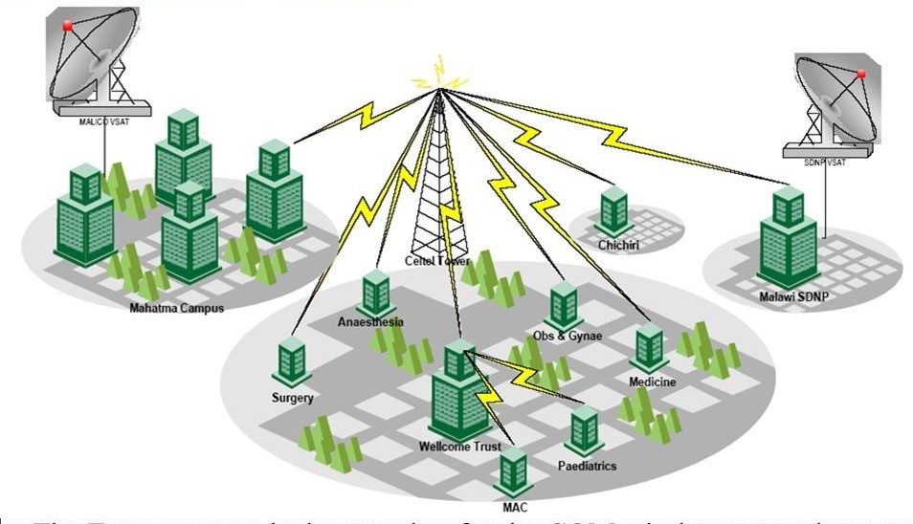

Figure 1 Example of a Campus Network Architecture [3]

A lot of challenges and obstacles will show up upon deciding to build a campus network like the creation of VLANs, implementation of strong firewall and adding campus VPNs.

To build a campus network, we need routers, switches, IP-phones, PCs and servers. Based on the size of the network we’re talking about; network requirements will be determined. Before doing any design or implementation, some planning must be done first.

In [4], a campus network was designed which is covering enormous area of about 2575 acres, the whole academy included a hospital, 2 middle schools and almost 3 million students enrolled to the network. Mainly, the design was divided as follows; (Core Layer as 1st layer, Convergence Layer as 2nd layer and as 3rd layer Access Layer). Core layer consists of 3 types of wire-speed Cisco routers and a backbone one. Convergence layer built of the “multi-mode fiber”. Access Layer is the layer where the full network looks as a tree.

## **1.2 - IP Addressing and Sub-netting**

Internet protocol address is a numerical label assigned to a specific device to be able to use it as a host or as network interface identifying and location addressing. We have to 2 versions of IPs (IPV4 & IPV6). IPV6 was used because all the IPV4 addresses were used up.

Sub-netting is the act of dividing big IP network into smaller ones that all can be separate from each other but share the same host identifier & in our case the campus identifier.

Every IP class has its own subnet mask, every subnet mask has fixed number of networks and fixed number of hosts.

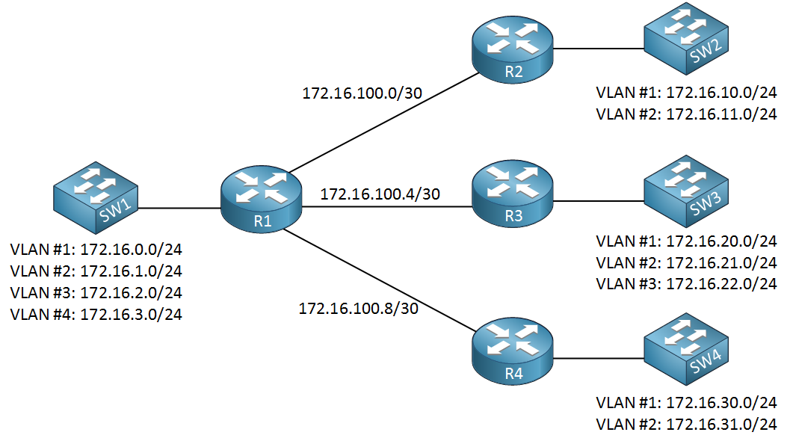

Figure 2 Example of a sub-netting process [5]

## **1.3 - Open Shortest Path First (OSPF)**

OSPF is an example of a Link-State routing protocol that is deployed within a single Autonomous System (AS) and these types of protocols are called Interior Gateway Protocols (IGP). Link-State routing protocols operate in the manner that each router exchanges its network topology information with its directly connected neighbors, while also receiving topology information from its neighbors, this process is performed by the exchange of Link-State Advertisement (LSA) messages until convergence is reached, where each router has built its own database representing the topology. A routing table with the best path chosen to reach any other device contributing in the network is built using for example the Dijkstra algorithm, at this point convergence has been reached. The main advantage of Link-State routing protocols is that upon reaching convergence each router will have a full view of the network topology [6].

OSPF protocol can be implemented in two techniques; Firstly the process of OSPF implementation divides the network topology into multiple areas (Multi-Area OSPF) where an area 0 called the **backbone area**holds the most critical devices of the network (backbone routers) and any traffic between the other areas must pass through the backbone area, a router having its ports connecting to more than one area are called Area Border Routers (ABR) the multi-area approach is used within large networks e.g. a given organization having a big site with multiple buildings in different locations. The Second approach is the Single-Area OSPF implementation, where only one area exists in the network (area 0) and this approach is most commonly used in a small organization’s campus e.g. in a university.

# Chapter 2

**Methodology**

## **2.1- Network Architecture**

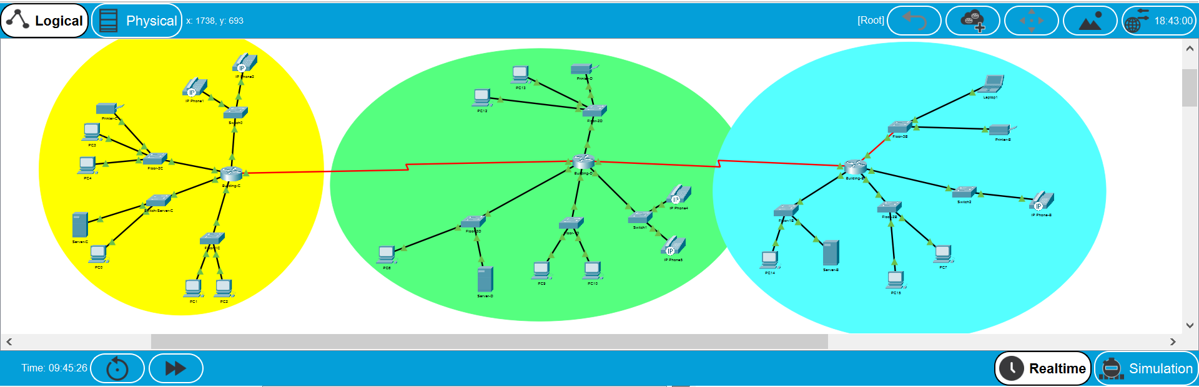

Figure 3 Our Campus Network Design

In this work, our network design aimed to simulate an example of a network architecture that can be deployed on the campus of our university. Moreover, there are 3 defined buildings in our design; **C, D and B**, which are the **Yellow, Green and Blue** respectively as shown in *Figure (3)* above.The network design assumed that each building had multiple floors; also devices used in this implementation were; PCs, Laptops, a central server for each building, IP-Phones, Printers, routers and switches.Furthermore, this network design’s routers used **OSPF** as their routing protocol and each building has a central router acting as its gateway. The **Sub-netting** technique was applied in the process of assigning IP-addresses to all devices present in the network, having a total of 14 subnets.

## **2.2- Sub-netting**

In this work 5 networks were used to be sub-netted to 14 subnets in order to assign IP-addresses to all contributing devices in the network, these networks are:

1. **192.168.4.0/26🡪 Building-D**
2. **192.168.5.0/26🡪 Building-B**
3. **192.168.6.0/30🡪 Routers Building-C and Building-D serial connection**
4. **192.168.7.0/30🡪 Routers Building-D and Building-B serial connection**
5. **192.168.8.0/26🡪 Building-C**

Moreover, we explain the sub-netting process for the **192.168.4.0/26** and **192.168.6.0/30** networks, the rest of the networks are had a similar process of sub-netting:

1. **192.168.4.0/26**

Firstly, the network had the address 192.168.4.0**/24.** We needed **4** subnets for this network, thus 2 additional bits were needed to satisfy this leading to /**26,** meaning there are (32-26 = 6) 6 bits remaining for the hosts, thus each subnet could accommodate 62 hosts ((2power6) – 2(broadcast and network addresses)). This resulted in the following subnets:

**192.168.4.0 🡪 192.168.4.63**

**192.168.4.64 🡪 192.168.4.127**

**192.168.4.128 🡪 192.168.4.191 Subnet-mask: 255.255.255.192**

**192.168.4.192 🡪 192.168.4.255**

1. **192.168.6.0/30**

The network had the address 192.168.6.0**/24.** We needed **1** subnet for this network, thus to satisfy having 1 address for each router’s port this lead to /**30,** meaning there are (32-30 = 2) 2 bits remaining for the hosts, thus the subnet could accommodate 2 hosts ((2power2) – 2(broadcast and network addresses)). This resulted in the following subnet:

**192.168.6.0 🡪 192.168.6.3 Subnet-mask: 255.255.255.252**

## **2.3 –Single-Area OSPF**

In this work the OSPF single area routing protocol was used in our campus network. OSPF single-area was chosen over the OSPF multi-areas because our campus network is a small network working with few routers and less complex. In the Single area we only have area 0, the backbone area connects the different buildings B, C & D routers in one area. The routers in the backbone area share the same link state information in their link stat databases [7].

## **2.4 – Router Configurations**

As show in the above *Figure (3)*,we have the routers with the names Building-C, Building-D and Building-B which act as a gate-way if any device in a building wants to communicate with another device in the same building or another building. To connect each router to our network, the OSPF protocol was used where we add the network IP address of the interface between the two routers. Moreover, to connect the other subnets (floors) in the same building we add the network IP address of each subnet (floor). So we have the floors of each building connected together and to other building floors, all following the OSPF routing protocol. The following *Figure (4)* will show the commands used in the Building-C router. The same configurations were used in the other buildings routers.

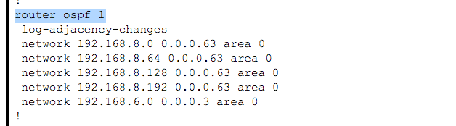

Figure 4 OSPF Router Configurations

## **2.5- End-Devices Configurations**

After calculating the subnet of each floor, an IP address and within the range of the subnet, subnet mask and the default-gateway for the port of the router that subnet is connected on were assigned to each PC, laptop, printer or server in this subnet. The following *figure (5)* shows an example of assigning the addresses for an end device.

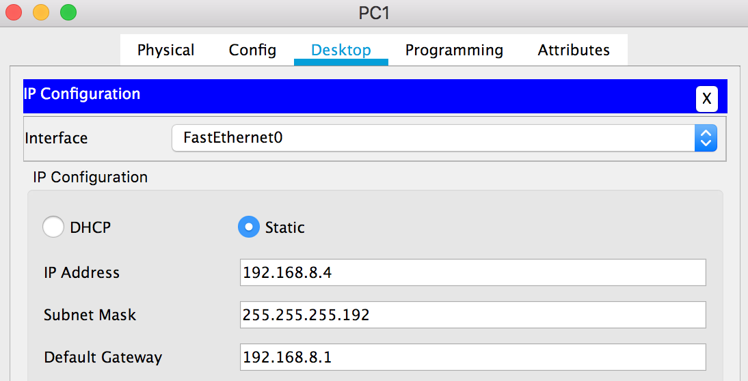

Figure 5 PC Configuration Example

## **2.6- Switch Configurations**

On the other hand, there were configurations for each switch in the network. Two types of switches were used in our campus design, Switch-PT for the end devices and Switch 2960-24TT for the IP phones as the other switch doesn’t support the ip phones configurations.

The switches-PT were used to connect the end devices of each subnet. The interfaces that are connected to the end devices were set to be on (using no shutdown command) and were set to the access mode. The interface that connects the switch to the router was set to trunk mode to carry traffic of many devices or Vlans. The same default-gateway in the end devices were added to the switch so they can be controlled remotely or communicate with other networks.

The switches 2960-24TT that were used to connect the IP phones had a different set of configurations. A voice vlan was defined in order to carry voice traffic. Interfaces in which the IP phones were connected on were access mode. as shown in the following figure (6).

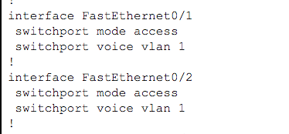

Figure IP Phone Switch Configurations

## **2.7- IP Phones**

IP-Phones were used to allow VoIP (voice over IP) in our network. VoIP is a means of allowing telephony services over an IP Network i.e. Internet instead of typical PSTN or mobile network. The model used was the Cisco IP Phone 7960, which is displayed in Figure (7) below.

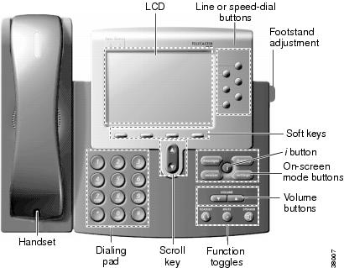

Figure 7IP PHONE Features [8]

In our architecture, there were IP-Phones placed in every building, where all these IP-phones needed to be able to connect and interact with one another. This was done through a few steps.

Firstly, on each router separately, a DHCP pool is created; which we named ***voice***. In this step, we set router to act as a DHCP server which is required to assign each IP phone associated to the network with an IP address. We assign this pool a network address and a default router IP address. The ***option 150*** command is then used to assign IP addresses to Cisco IP phones. This command is compulsory for VoIP configurations [11].

Secondly, similarly, on each router separately, the Call Manager Express telephony service was configured and then each directory entry is assigned with a given phone number i.e. the number dialed by other phones to communicate with it [11].

Finally, on each router, the ***dial-peer voice # voip*** command is used to allow both inbound and outbound peer communication; which allows IP phones within the same and different networks to be able to communicate with one another. To set this up, the ***session target*** and the ***destination pattern*** are required. The session target (only required for outbound peers) is the IP address of the next hop to reach this dial peer. The destination pattern correlates a certain dial string with a particular IP phone. This process is displayed in Figure (8) displayed below.

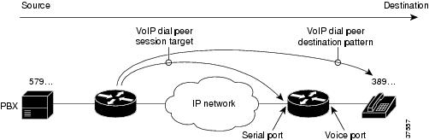

Figure 8Relationship Between Destination Pattern and Session Target [9]

Lastly, for the switch directly connected to the IP phone, a ***voice vlan*** must be created and configured for the switch to be able to separate the handling of voice and data packets.

# Chapter 3

**Conclusion**

To conclude, this work discusses a campus network design that constitutes 3 buildings connected using routers that use the OSPF routing protocol to communicate with one another. Each building separately consists of several floors that include end devices such as PCs, laptops, servers, printers and IP phones. All devices in the network can communicate and transfer both data packets as well as voice packets, which is achieved through the use of IP phones that allow VoIP (Voice Over IP) communication.

# References

[1] Ali, Md. Nadir. (2015). Design and Implementation of a Secure Campus Network. Journal of Surface Engineered Materials and Advanced Technology. 5.

[2] <https://www.ijeat.org/wp-content/uploads/papers/v5i4/D4549045416.pdf> (Last viewed on: 9/1/2021)

[3] <https://nsrc.org/workshops/2009/summer/presentations/day5/country/CoM_Malawi_Campus_Network.pdf> (Last viewed on: 9/1/2021)

[4] Xie Shuizhen. (2011). Planning, designing and building large-scale network at campus. 2011 3rdInternational Conference on Computer Research and Development. doi:10.1109/iccrd.2011.5764182

[5] <https://networklessons.com/cisco/ccna-routing-switching-icnd1-100-105/what-is-subnetting> (Last viewed on: 9/1/2021)

[6] <https://www.metaswitch.com/knowledge-center/reference/what-is-open-shortest-path-first-ospf> (Last viewed on: 3/1/2021)

[7] <https://networkustad.com/2019/08/31/single-area-and-multi-area-ospf/> (Last viewed on: 4/1/2021)

[8] <https://www.cisco.com/c/dam/en/us/td/i/000001-100000/35001-40000/38001-38500/38007.ps/_jcr_content/renditions/38007.jpg>(Last viewed on: 4/1/2021)

[9] <https://www.cisco.com/c/dam/en/us/td/i/000001-100000/35001-40000/37501-38000/37557.ps/_jcr_content/renditions/37557.jpg> (Last viewed on: 4/1/2021)

[10] <https://www.networkcomputing.com/data-centers/campus-network-design-models>(Last viewed on: 5/1/2021)

[11] <https://www.packettracernetwork.com/tutorials/voipconfiguration.html>(Last viewed on: 4/1/2021)